OCS
Oxford Cognitive Screen –Australian Version
Test Booklet
Version B
Year:_________
Site:__________

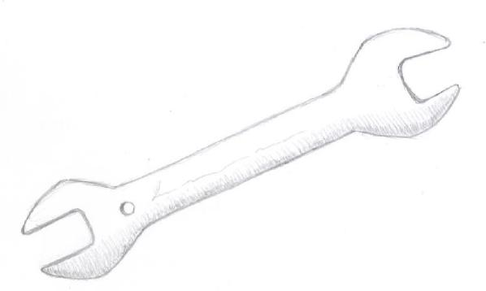
1

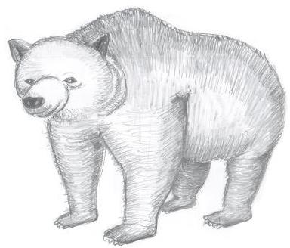
2

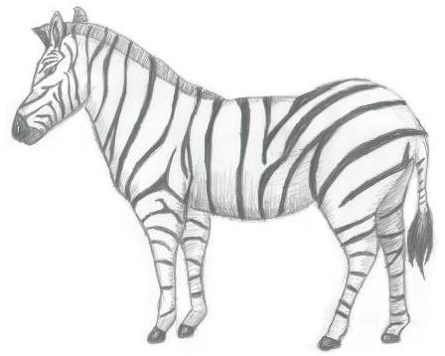
3

4

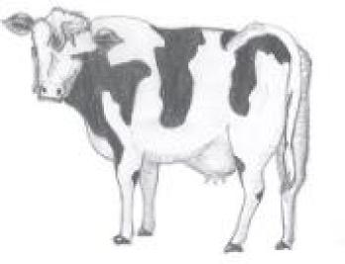
5

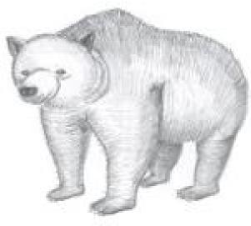

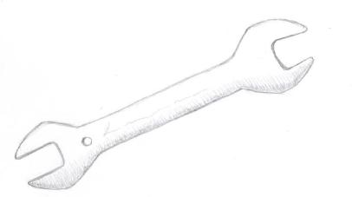

1) Which city or town are we in ?
6
[Correct city / town]

[Famous same size city / town]

[Nearby same size city / town]

[Famous nearby city]

2) What part of the day is it now?
7
Morning
Afternoon
Evening
Night

3) Can you tell me the month?
8
January
February
March
April
May
June
July
August
September
October
November
December

4) What is the year we are in now?
9

[199x]
(where 'x' is the last number of the current year, for example; in 2014 'x' is 4, in 2015 'x' is 5)

[Current year + 1]

[Current year – 1]

[Current year]

The chauffer drove
10

across the island to
see the choir, but
there was a queue.

5 + 4 =
11
5 + 4 =
12
8
9
10
14

16 +8 =
13
16 + 8 =
14
8
24
14
22

9 - 4 =
15
9 - 4 =
16
2
5
6
13

35 - 18 =
17

35 - 18 =
18
13
17
21
27

Which word was in the sentence?
19

driver
chauffeur
motorist
cabbie

Which word was in the sentence?
20
peninsula
atoll
island
reef

Which word was in the sentence?
21

chorus
singers
band
choir

Which word was in the sentence?
22

queue
line
row
stream
Which picture did you see before?
23
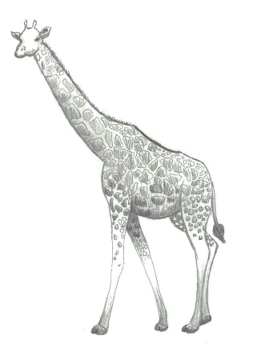
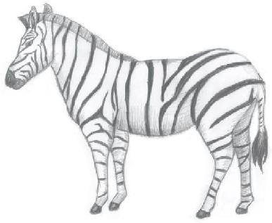
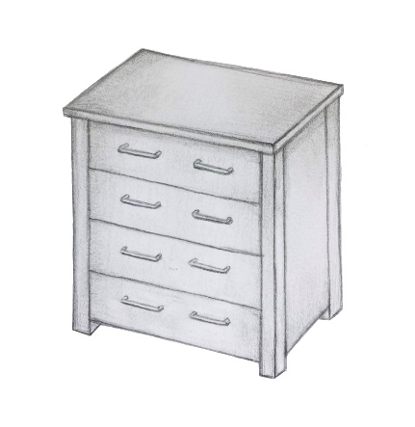

Which picture did you see before?
24
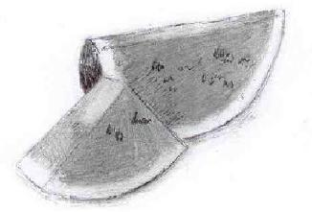
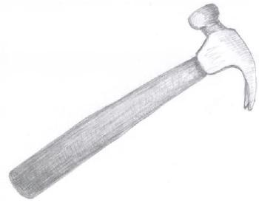

What did you do before?
25
(demonstrate)
Clap your hands
Make these finger positions
Snap your fingers
Count my fingers

What did you do before?
26
Rhyming
Sums
Word writing
Multiplications
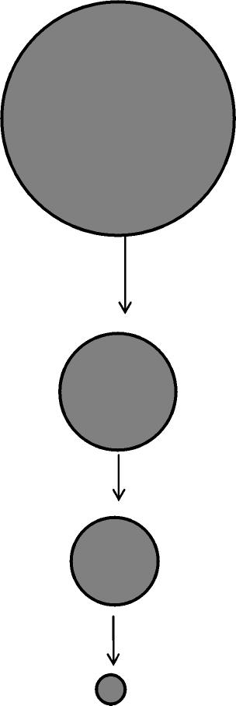
27

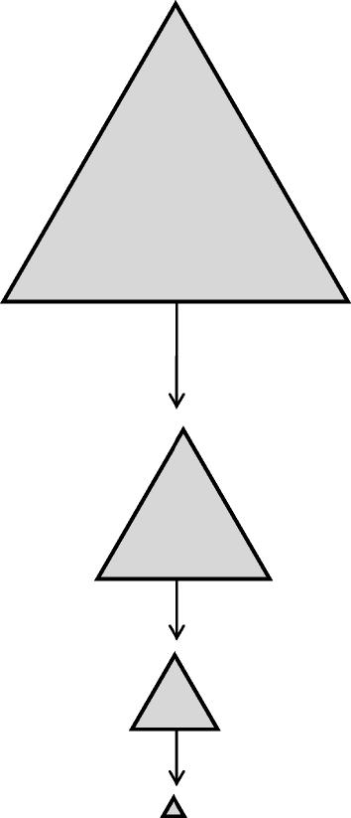
28

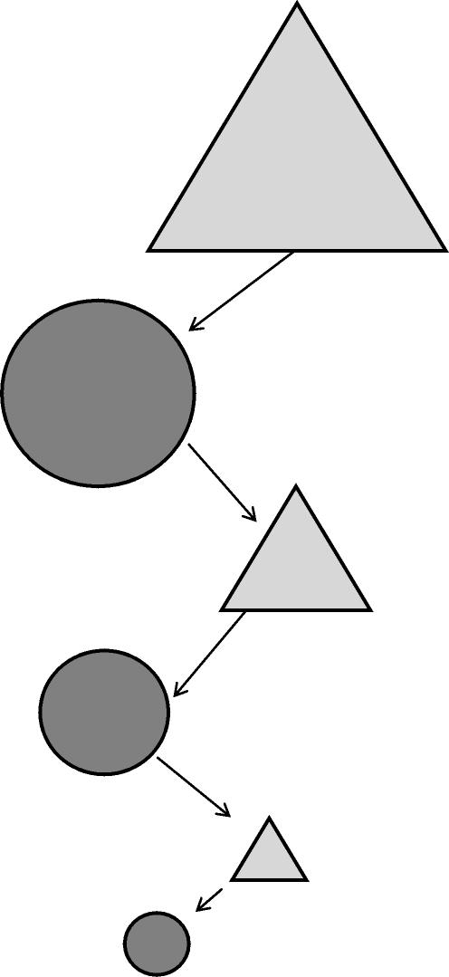
29

