OCS
Oxford Cognitive Screen –Australian Version
Test Booklet
Version A

Year: __________
Site: ____________

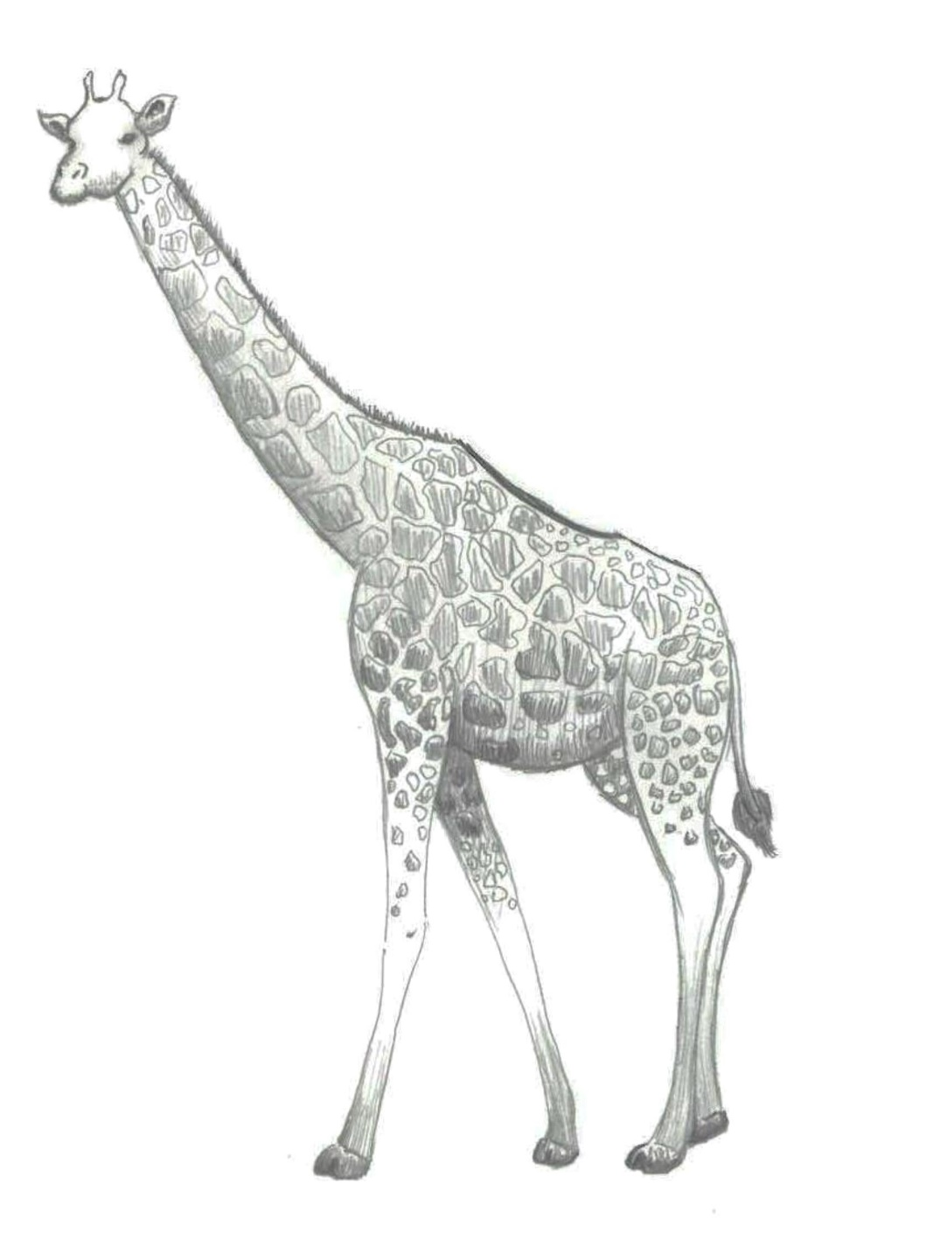
1

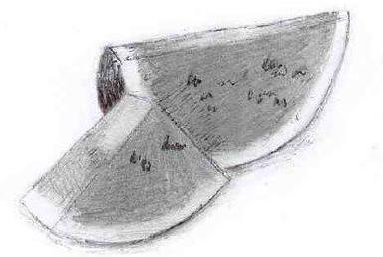
2

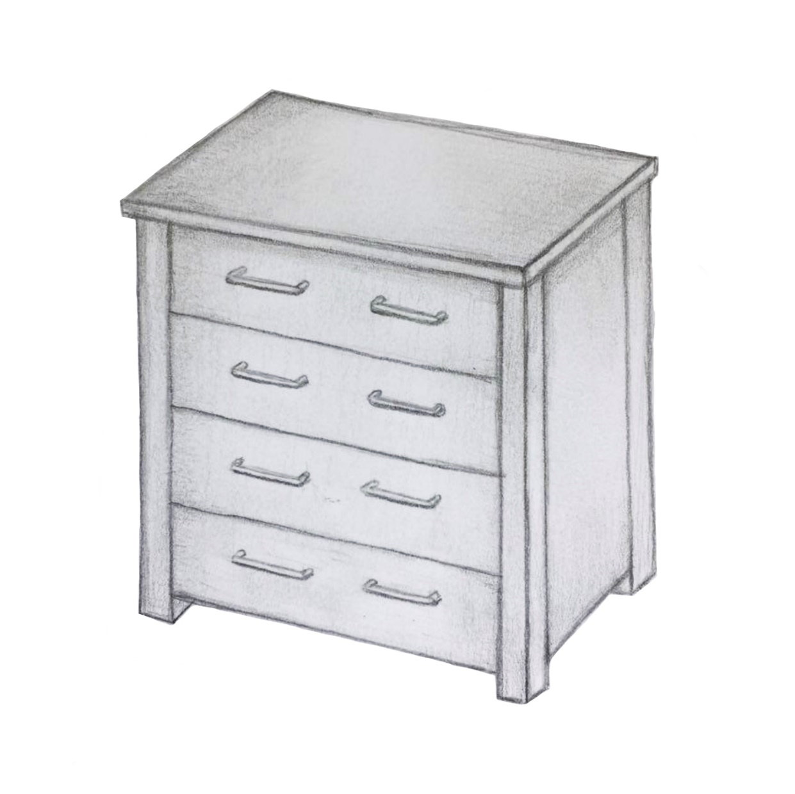
3

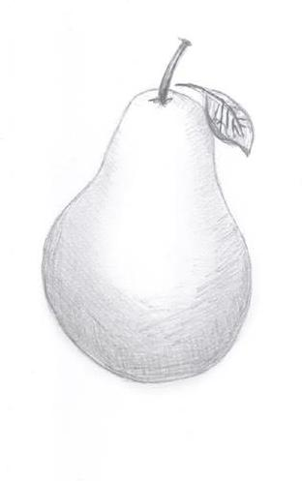
4

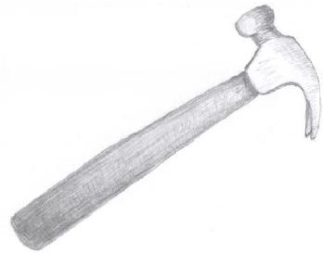
5
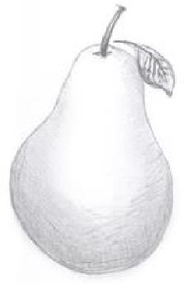
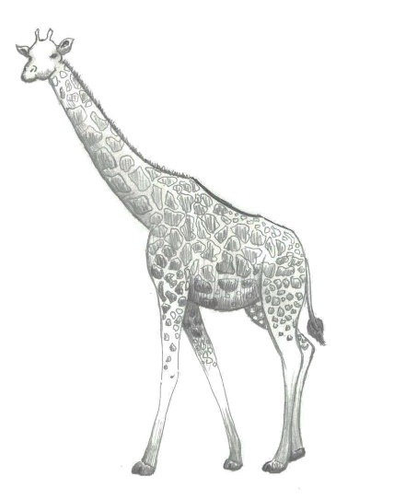

1) Which city or town are we in?
6

[Correct city / town]

[Famous same size city / town]

[Nearby same size city / town]

[Famous nearby city]

2) What part of the day is it now?
7
Morning
Afternoon
Evening
Night

3) Can you tell me the month?
8
January
February
March
April
May
June
July
August
September
October
November
December

4) What is the year we are in now?
9

[199x]
(where 'x' is the last number of the current year, for example; in 2014 'x' is 4, in 2015 'x' is 5)

[Current year + 1]

[Current year – 1]

[Current year]

10

As he was

kneading the dough,
the chef wished he
had bought some more flour.

6 + 3
11
6 + 3 =
12
8
9
10
14

7 + 9 =
13
7 + 9 =
14
4
14
16
22

8 - 5 =
15
8 - 5 =
16
2
3
6
13

36 - 17 =
17

36 - 17 =
18
11
19
21
29

Which word was in the sentence?
19

sifting
kneading
mixing
stirring

Which word was in the sentence?
20
mixture
batter
dough
pastry

Which word was in the sentence?
21

caterer
baker
cook
chef

Which word was in the sentence?
22
flour
sugar
butter
egg
Which picture did you see before?
23

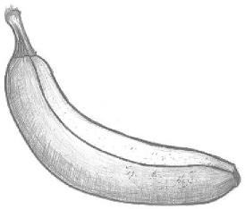
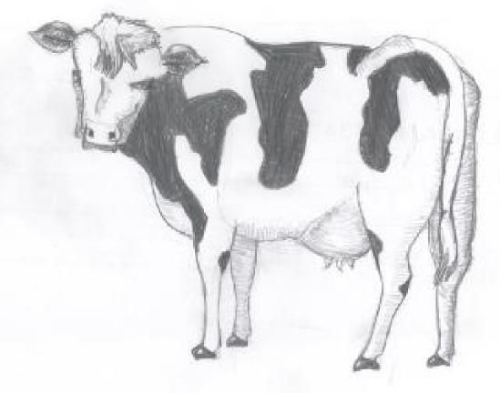
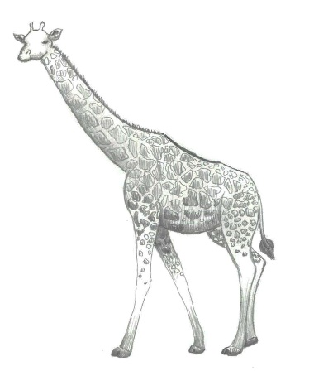
Which picture did you see before?
24
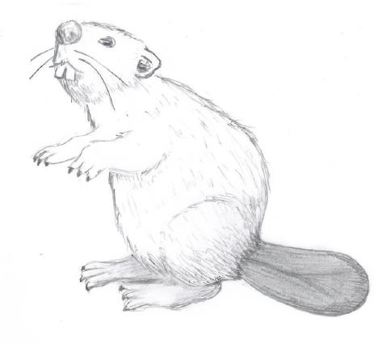
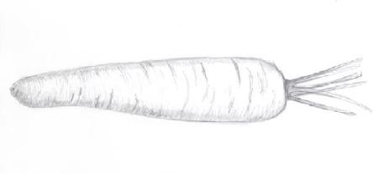
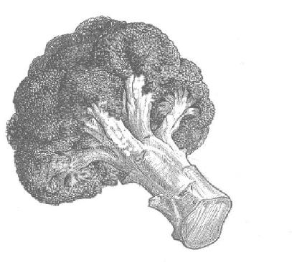

What did you cross out?
25

What did you write down?
26
words
letters
numbers
prices
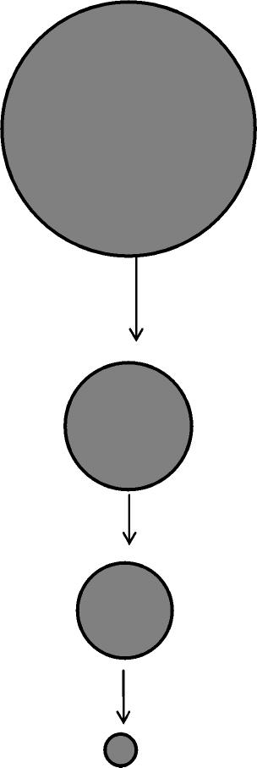
27

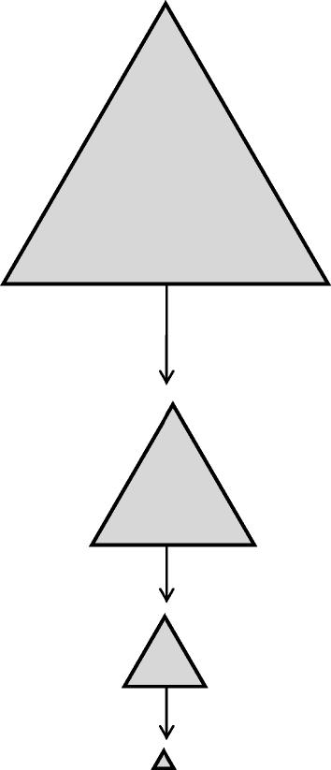
28
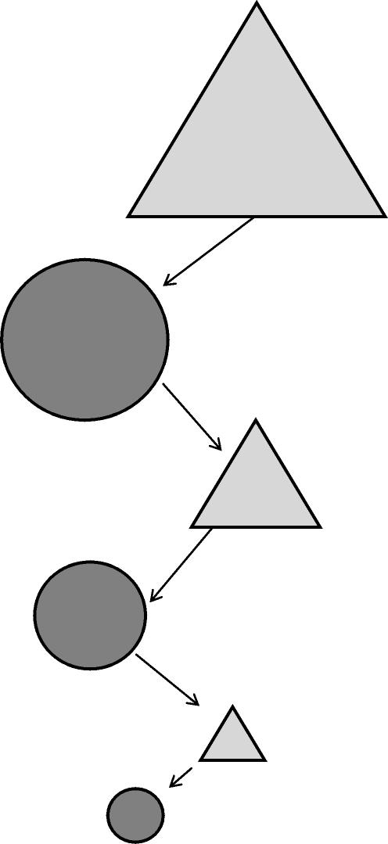
29

