PAIN COPING SKILLS PROGRAM
Participants’ Workbook
Pain Management Research Institute/Royal North Shore Hospital
(October, 2016) V10.4

This Participants’ Workbook is part of the Pain Coping Skills Program (PCSP) which is aimed at helping people with ongoing pain.

The program is based on the book ‘Manage Your Pain’. Each chart in the workbook is linked to a chapter in Manage Your Pain.

Other relevant resources include: ACI Website www.aci.health.nsw.gov.au/chronic-pain
Brain Man YouTube cartoon, Pete Moore’s Pain Toolkit available at http://www.aci.health.nsw.gov.au/chronic-pain/translated-resources.

The Pain Coping Skills Program, including the Facilitators’ Guide and Participants’ Workbook, was developed by several members of the staff at the Pain Management & Research Centre (PMRC) and the University of Sydney Medical School-Northern at Royal North Shore Hospital. Main authors: Michael Nicholas, Duncan Sanders, Catherine Ketsimur, Lois Tonkin, Maria De Sousa, Lee Beeston, John Waine, Brad Wood, Mayumi Oguchi, Sarah Overton, Jessica Castle, Tumelo Dube, and Charles Brooker.

The multi-language version was developed by a collaboration between ACI (Pain Network) and several multicultural health workers and pain clinicians in Sydney: Jennie Vien (Sydney LHD), Mark Rusconi (NSLHD), Eva Melham (WSLHD) Tran Nguyen (SWSLHD), Luke O’Connell (NBMLHD), Hanaar Nosir (WSLHD), Wlima Espinoza (SESLHD). Seok Ohr (HNELHD), Carmen Lopez (SWSLHD), Maree Lindsay (ISHLHD), Amal Helou (SLHD), Angela Manson (SLHD).

LIST OF CONTENTS

PAIN PROGRAM TIMETABLE 3
COMMON PROBLEMS EXPERIENCED BY PEOPLE WITH CHRONIC PAIN 4
MY GOAL CHART 5
ACTIVITY / EXERCISE SESSION ROOM LAYOUT 6
ACTIVITY/ EXERCISE CHART 7
ACTIVITY CHART – STEP BY STEP 100
RELAXATION PRACTICE CHART 12
WEEKLY PLAN (1) 15
WEEKLY PLAN (2) 16
WEEKLY PLAN (3) 17
WEEKLY PLAN (4) 18
WEEKLY PLAN (5) 19
WEEKLY PLAN (6) 200
PROBLEM SOLVING/STRESS MANAGEMENT 211
PLANNING FOR WHEN PAIN GETS WORSE (Example) 222
MY PLAN FOR WHEN PAIN GETS WORSE 233
COMMUNICATION ISSUES 244
PLANNING FOR STAYING ON TRACK 25
MY LONG-TERM PLANS 26
MULTICULTURAL RESOURCES – STRESS, RELAXATION AND WELLBEING

PAIN PROGRAM TIMETABLE

There is one 2.5-hour session per week for six weeks.
TIME | Session 1 | Session 2 | Session 3 | Session 4 | Session 5 | Session 6
20 Min | DISCUSSION  Feedback,  Plan for today | DISCUSSION  Feedback,  Plan for today | DISCUSSION  Feedback,  Plan for today | DISCUSSION  Feedback,  Plan for today | DISCUSSION  Feedback,  Plan for today | DISCUSSION  Feedback,  Plan for today
15 Min | RELAXATION  In daily life | RELAXATION  In daily life | RELAXATION  In daily life | RELAXATION  In daily life | RELAXATION  In daily life | RELAXATION  In daily life
30 Min | ACTIVITY/ EXERCISE CIRCUIT | ACTIVITY/ EXERCISE CIRCUIT | ACTIVITY/ EXERCISE CIRCUIT | ACTIVITY/ EXERCISE CIRCUIT | ACTIVITY/ EXERCISE CIRCUIT | ACTIVITY/ EXERCISE CIRCUIT
20 Min | COFFEE  BREAK | COFFEE  BREAK | COFFEE  BREAK | COFFEE  BREAK | COFFEE  BREAK | COFFEE  BREAK
30 Min | PROBLEM-SOLVING  (When pain increases) | PROBLEM-SOLVING  (Stress) | PROBLEM-SOLVING (Communication) | PROBLEM-SOLVING  (Planning for staying on track) | PROBLEM-SOLVING  (Sleep) | PROBLEM-SOLVING  (Nutrition)
25 Min | ACTIVITY  PLANS  (Step by step) | ACTIVITY PLANS  (Step by step) | ACTIVITY  PLANS  (Step by step) | ACTIVITY PLANS  (Step by step) | ACTIVITY PLANS  (Step by step) | ACTIVITY PLANS  (Step by step)
10 Min | HOME TASKS | HOME TASKS | HOME TASKS | HOME TASKS | HOME TASKS | HOME TASKS

PROBLEMS OFTEN EXPERIENCED BY PEOPLE WITH CHRONIC PAIN 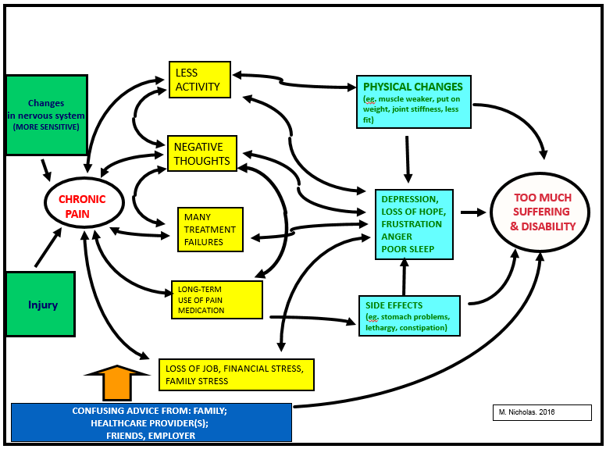

MY GOAL CHART

 | MY GOALS  (What it is I want to achieve – be specific) | Changes I can make over next 6 weeks  (Things I need to do/work on to achieve my goals) | At the end of program, rate how you are going  (0-100%)
Example  Home tasks or activities | “Wash the dishes at least 3 times a week” | “Increase my standing time  (to 15 minutes)”
Paid work/study/ voluntary work
Family activities/ relationships
Social activities
Recreation/sport/ hobbies
Other

DON’T LET PAIN CONTROL YOUR LIFE
You can end up doing less and less
- Many people who have chronic pain use pain to guide their daily activities
- When the pain is less, they do more. But when the pain is worse, they do less and rest more
- This approach can seem OK, but it can cause problems
- The main problem is that you will do less and less. The diagram below shows what can happen WHEN PAIN CONTROLS YOUR LIFE
- Some people call this a too much/too little approach and it often ends up in you taking more pain medication and being more frustrated when you can’t do things you planned to do.
- A better way to do things is to do them a step at a time and slowly do more as you get fitter
- This is what we would like you to try in this program.
- This means taking more time over things, taking short breaks, and avoiding long breaks
To get started:
- Work out how much or how long you can do each activity comfortably. It might be 5 minutes or 20 metres, depending on the activity (like walking or sitting)
- We call this your starting point.
- Next, try to use that amount as your guide on when to stop the activity and take a short break.
- After the short break, do your next activity, but keep to your starting point.
- Every second or third day you should try to do a little more of each activity.
- We call this activity stepping. It is based on planned targets and not pain. It can help you to do more without more pain. See the diagram below of what it looks like.
A BETTER, SMARTER WAY:
TAKE A STEP BY STEP APPROACH TO ACTIVITIES
ACTIVITY / EXERCISE CIRCUIT

ACTIVITY/ EXERCISE CIRCUIT CHART (Tick when done )
Start Date: | Sit-to-Stand | Step-ups | Lunge | Walking (and carrying) | All 4’s hip extension | Push-ups (wall or standard) | Lifting  (squat ± weights) | Lifting (overhead press) | Single leg balance | Back Stretch
(tick when you complete target for each activity in 1 ½ minutes) | 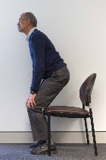 | 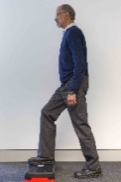 | 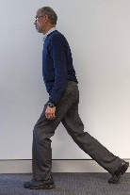 | 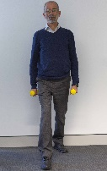 | 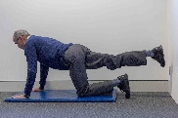 | 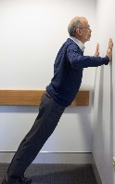 |  | 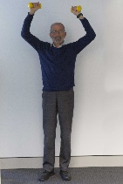 | 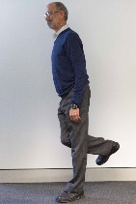 | 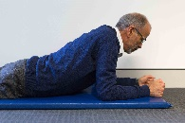
Day 1
Day 2
Day 3
Day 4
Day 5
Day 6
Day 7
Day 8

 | Sit-to-Stand | Step-ups | Lunge | Walking (and carrying) | All 4’s hip extension | Push-ups (wall or standard) | Lifting  (squat ± weights) | Lifting (overhead press) | Single leg balance | Back Stretch
Day 9
Day 10
Day 11
Day 12
Day 13
Day 14
Day 15
Day 16
Day 17
Day 18
 | Sit-to-Stand | Step-ups | Lunge | Walking (and carrying) | All 4’s hip extension | Push-ups (wall or standard) | Lifting  (squat ± weights) | Lifting (overhead press) | Single leg balance | Back stretch
Day 19
Day 20
Day 21
Day 22
Day 23
Day 24
Day 25
Day 26
Day 27
Day 28
 | Sit-to-Stand | Step-ups | Lunge | Walking (and carrying) | All 4’s hip extension | Push-ups (wall or standard) | Lifting  (squat ± weights) | Lifting (overhead press) | Single leg balance | Back Stretch
Day 29
Day 30
Day 31
Day 32
Day 33
Day 34
Day 35
Day 36
Day 37
Day 38
 | Sit-to-Stand | Step-ups | Lunge | Walking (and carrying) | All 4’s hip extension | Push-ups (wall or standard) | Lifting  (squat ± weights) | Lifting (overhead press) | Single leg balance | Back Stretch
Day 39
Day 40
Day 41
Day 42
Day 43
Day 44
Day 45
Day 46
Day 47
Day 48

ACTION CHART – Important Daily Activities
(Choose which ones you want to do)
 | Sitting  (time) | Standing  (time) | Bending  (repetitions) | Walking |  | Squatting  (time) | Carrying |  | Lifting |  | Reaching |  | Climbing |  | Key  board
 |  |  |  | Dist | Time |  | Weight | Dist | Weight | Repetitions | Forwd | Above | Steps | Ladder
What you can do now?
Starting level (for each activity you choose)
DAY | Goal | Goal | Goal | Goal | Goal | Goal | Goal | Goal | Goal | Describe | Goal | Goal | Goal | Goal | Goal
1
2
3
4
5
6
7
8
9
10
11

 | Sitting  (time) | Standing  (time) | Bending  (repetitions) | Walking |  | Squatting  (time) | Carrying |  | Lifting |  | Reaching |  | Climbing |  | Key  board
 |  |  |  | Dist | Time |  | Weight | Dist | Weight | Repetitions | Forwd | Above | Steps | Ladder
DAY | Goal | Goal | Goal | Goal | Goal | Goal | Goal | Goal | Goal | Describe | Goal | Goal | Goal | Goal | Goal
12
13
14
15
16
17
18
19
20
21
22
23
24
25
26
27
28

 | Sitting  (time) | Standing  (time) | Bending  (repetitions) | Walking |  | Squatting  (time) | Carrying |  | Lifting |  | Reaching |  | Climbing |  | Key  board
 |  |  |  | Dist | Time |  | Weight | Dist | Weight | Repetitions | Forwd | Above | Steps | Ladder
DAY | Goal | Goal | Goal | Goal | Goal | Goal | Goal | Goal | Goal | Describe | Goal | Goal | Goal | Goal | Goal
29
30
31
32
33
34
35
36
37
38
39
40
41
42
43
44

 | Sitting  (time) | Standing  (time) | Bending  (repetitions) | Walking |  | Squatting  (time) | Carrying |  | Lifting |  | Reaching |  | Climbing |  | Key  board
 |  |  |  | Dist | Time |  | Weight | Dist | Weight | Repetitions | Forwd | Above | Steps | Ladder
DAY | Goal | Goal | Goal | Goal | Goal | Goal | Goal | Goal | Goal | Describe | Goal | Goal | Goal | Goal | Goal
45
46
47
48
49
50
51
52
53
54
55
56
57
58
59
60

RELAXATION PRACTICE CHART
Select a way of relaxing that you would like to use (see Multicultural resources section). The times are only a guide (even 30 seconds at a time can be helpful). Tick the chart each time you do it.Two long sessions a day (15-20 min) in a quiet place. Practice short sessions (30-60 seconds) in different places and especially if feeling stressed or noticing more pain.
Day | 20 min | 20 min | 30-60 sec | 30-60 sec | 30-60 sec | 30-60 sec | 30-60 sec | Notes/comments
1
2
3
4
5
6
7
8
9
10
11
12
13
14
15
16
17
18
RELAXATION PRACTICE CHART Each time I do it
Day | 20 min | 20 min | 30-60 sec | 30-60 sec | 30-60 sec | 30-60 sec | 30-60 sec | Notes/comments
19
20
21
22
23
24
25
26
27
28
29
30
31
32
33
34
35
36
37
38
RELAXATION PRACTICE CHART Each time I do it
Day | 20 min | 20 min | 30-60 sec | 30-60 sec | 30-60 sec | 30-60 sec | 30-60 sec | Notes/comments
39
40
41
42
43
44
45
46
47
48
49
50
51
52
53
54
55
56
57
58

WEEKLY PLAN (1)
Plan your days over the next week. Try to space tasks through the day and make times for breaks. Tick them off as you go.
 | Day 1 |  | Day 2 |  | Day 3 |  | Day 4 |  | Day 5 |  | Day 6 |  | Day 7 | 
AM

PM

N
i
g
h
t

WEEKLY PLAN (2)
Plan your days over the next week. Try to space tasks through the day and make times for breaks. Tick them off as you go.
 | Day 1 |  | Day 2 |  | Day 3 |  | Day 4 |  | Day 5 |  | Day 6 |  | Day 7 | 
AM

PM

N
i
g
h
t

WEEKLY PLAN (3)
Plan your days over the next week. Try to space tasks through the day and make times for breaks. Tick them off as you go.
 | Day 1 |  | Day 2 |  | Day 3 |  | Day 4 |  | Day 5 |  | Day 6 |  | Day 7 | 
AM

PM

N
i
g
h
t

WEEKLY PLAN (4)
Plan your days over the next week. Try to space tasks through the day and make times for breaks. Tick them off as you go.
 | Day 1 |  | Day 2 |  | Day 3 |  | Day 4 |  | Day 5 |  | Day 6 |  | Day 7 | 
AM

PM

N
i
g
h
t

WEEKLY PLAN (5)
Plan your days over the next week. Try to space tasks through the day and make times for breaks. Tick them off as you go.
 | Day 1 |  | Day 2 |  | Day 3 |  | Day 4 |  | Day 5 |  | Day 6 |  | Day 7 | 
AM

PM

N
i
g
h
t

WEEKLY PLAN (6)
Plan your daily routine over the next four weeks. Try to space tasks through the day and make times for breaks. Tick them off as you go.
 | Day 1 |  | Day 2 |  | Day 3 |  | Day 4 |  | Day 5 |  | Day 6 |  | Day 7 | 
AM

PM

N
i
g
h
t

PROBLEM SOLVING/STRESS MANAGEMENT

Step 1: What is the problem?
Think about and discuss the problem or goal carefully, then write down exactly what you think is the main problem or goal.

_______________________________________________________________________________________________________
Step 2: List all possible solutions
Try to think of all possible solutions, even bad ones.

______________________________________________________________________________________________________
Step 3: Choose the best or most practical solution for you
Choose the solution that you think would be easiest for you.

________________________________________________________________________________________________________
Step 4: Do it!

_________________________________________________________________________________________________________
Step 5: Review how well it worked. Try to think about how you might do it better next time.

WHAT YOU MIGHT DO WHEN YOUR PAIN GETS WORSE (This is an example)
Develop your own plan once you’ve thought about the steps in this example
Step One | Step Two | Step Three
Stop and assess  - Is this a new pain, or my usual pain?  - What might have caused this?  - Have I been overdoing activities?  - Have I been feeling stressed?  (Take time, check if I have had any  negative thoughts)  - No broken bones?  - What do I usually do when this happens? – Is it working or is it time to change? | Consider options  - Plan my next actions  - Take short break?  - Relax (work on my breathing)?  - Respond to any negative thoughts  - Take it bit by bit  - Cutting back on activities?  - Tell others what’s happening and how they can help? | Check on my progress  - How am I going?  - Using strategies?  - Other options?  - Reassure myself  - Reward yourself for trying  - Do I need to do less or more?  - Goals for next week?

MY PLAN FOR WHEN MY PAIN GETS WORSE

Step One | Step Two | Step Three
Stop and assess  (Take time, check any  negative thoughts) | Consider my options | Check how I’m going

COMMUNICATION ISSUES
PROBLEMS | POSSIBLE SOLUTIONS
Example: How do I tell other people I still have my pain? I find it difficult to explain and often feel stressed. | - I could use my relaxation technique (of letting go of tension while breathing out),  - Smile and say, “yes, I was surprised too, but my physio and doctor have helped me to understand that pain can continue even after an injury has healed”  - “I just have to learn to live with it”.  - “And that’s what I’m doing”

STAYING ON TRACK WITH MY PROGRAM
BENEFITS OF STAYING ON TRACK: ______________________________________________________________________________________________________
______________________________________________________________________________________________________
IF I DON’T STAY ON TRACK – WHAT MIGHT HAPPEN? _______________________________________________________
______________________________________________________________________________________________________
WHAT MIGHT STOP ME? | SOLUTIONS

MY NIGHT TIME SLEEP PLAN
PROBLEMS | POSSIBLE SOLUTIONS
Example: Waking in middle of night, pain disturbing me, can’t get back to sleep | - Change position;  - Practice my relaxation exercise (not trying to sleep, just to enjoy relaxing); see what happens.  - If not asleep after 20 minutes or so, get up and go to another room  - Practice relaxing again or read book / magazine (avoid interesting movies on TV and loud music),  - Return to bed and relax again

PROBLEMS | POSSIBLE SOLUTIONS
Example: Trouble saying “no” when offered more food | - Explain that for my health problems I have been instructed by my doctor to limit my food intake  - Try healthy options (fruit, vegetables, water)
HEALTHY EATING PLAN

AT END OF COURSE, MY LONG-TERM PLANS – FOR NEXT 6-12 MONTHS
 | MY LONG-TERM PLANS  (What it is I want to achieve – be specific) | Changes I can make over next 6-12 MONTHS  (Things I need to do/work on to achieve my plans)
Home tasks or activities
Paid work/study/ voluntary work
Family activities/ relationships
Social activities
Recreation/sport/ hobbies
Other

Multicultural Resources – Stress, Relaxation and Wellbeing
AUDIO | Greek | Vietnamese | Cantonese | Mandarin | Arabic
STARTTS  RELAXATION CD $16  http://www.startts.org.au/resources/resources-for-sale/relaxation-cd/ |  | √√ | √√ |  | √
https://www.seslhd.health.nsw.gov.au/multicultural_health/audio_playlist.asp  Russ Harris mindfulness techniques | √ |  |  |  | √
QPASTT - $10 fee  http://qpastt.org.au/tbcwp1/wp-content/uploads/2014/08/QPASTT_Order_Form_2014_2.pdf  Relaxation Audio CDs - Progressive Relaxation and Mindfulness Practice |  |  |  |  | √
You tube clips provide a wealth of resources – however, search terms will be most effective when used in language you are wanting to hear the audio file in.
Audio recording of possible Vietnamese guided meditations http://langmai.org/phapduong/nghe-phap-thoai-audio |  | √

Handouts/fact sheets | Greek | Vietnamese | Simplified Chinese | Traditional Chinese | Arabic
Good night’s sleep | √ | √ | Chinese | Chinese | √
A Practical Guide About Problem Solving | √ | √ | Chinese | Chinese | √
Promoting Wellbeing | √ | √ | Chinese | Chinese | √
A Practical Guide about Stress | √ | √ | Chinese | Chinese | √
Wellbeing – Invest in your life | √ | √ | √ | √ | √
Relaxed Breathing | √ |  | √

http://psychology.tools/download-therapy-worksheets.html - A range of tools, worksheets, fact sheets in a variety of languages about everything related to psychology; including types of therapy, checklists etc.
Simplified Chinese | http://psychology.tools/simplified-chinese-用于治疗的cbt工作表-免费下载.html
Traditional Chinese | http://psychology.tools/traditional-chinese-下載治療用工作表單.html
Arabic | http://psychology.tools/arabic-نزٌل-اوراق-عمل-علاجية.html
Greek | http://psychology.tools/greek-κατεβάστε-φύλλα-εργασίας-θεραπείας.html
Published Oct 2017. ACI/D23/892 © State of NSW (Agency for Clinical Innovation)

