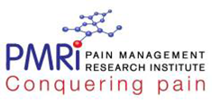

**Community management programme**

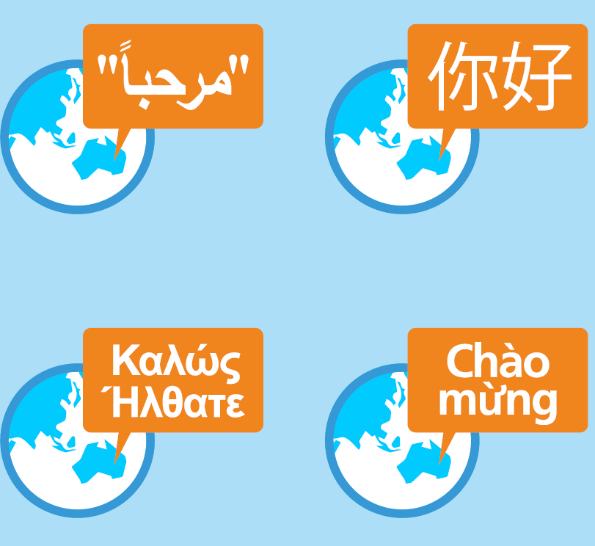

Published Oct 2017. ACI/D23/885 © State of NSW (Agency for Clinical Innovation)

**A brief programme to learn skills in pain management for multicultural communities**

Tool Box