Instructions for
Clinical genetics: Referral criteria template
This document is part of the Clinical Genomics Model of Care Toolkit and is intended to be used together with the Agency for Clinical Innovation’s (ACI) Clinical Genomics Model of Care.
- This template is for local health districts (LHDs) and hospitals to populate and make available for primary care clinicians, medical specialists and patients.
- You can add the details and logo for the LHD or hospital into the header and footer where indicated on each page.
- The blue text indicates areas for you to populate with the details for your LHD or hospital. Please delete the blue text once the document has been populated.
- This template has been built as an adaptable template to allow hospitals and LHDs to customise it as required.
- Once completed, save the document as a pdf excluding page 1 (instructions for use).
- Publish referral criteria on the hospital or LHD website.

Clinical genetics: Referral criteria
<Insert hospital and service name e.g. Royal North Shore Hospital Ambulatory Care Centre>
Insert hospital logo here

<Insert hospital name> provides the following genetics clinics:
- Genetics Counsellor Clinic
- Insert clinic name Genetics Clinic
- Insert clinic name Genetics Clinic
- Insert clinic name Genetics Clinic
- Insert clinic name Genetics Clinic
- Insert clinic name Genetics Clinic

Mandatory referral information
All genetics referrals must include a consultant being referred to in outpatients. If unsure, please address
to <insert head of department name> and Associates.
All referrals must include:
- patients’ details
- provisional diagnosis and reason for referral
- findings and treatments to date
- how this affects the patient
- significant medical history
- list of medications
- relevant social information
- if an interpreter is required and preferred language.
A referral form is provided containing all this information.
Please clearly indicate if this referral relates to an ongoing pregnancy.
Please attach results of any investigations to the referral and ensure the patient brings hard copies to their appointment.
Referrals with insufficient information will be returned to the referring doctor until further information is provided to the clinic.

Urgent referrals
The following should be referred urgently by contacting the <insert name of hospital> switchboard <insert phone number> and ask to page the on-call genetics fellow, geneticist or genetic counsellor:
- <Insert urgent referral criteria>
For example:
- pregnant patients
- cancer patients scheduled for surgery or therapies where genetic testing will be required for immediate surgical or treatment options
- patients where results of the genetic consultation are required for urgent medical management decisions.

Clinical genetics: Referral criteria
<Insert hospital and service name e.g. Royal North Shore Hospital Ambulatory Care Centre>
Insert hospital logo here

<Insert hospital name> provides the following genetics clinics:
- Genetics Counsellor Clinic
- Insert clinic name Genetics Clinic
- Insert clinic name Genetics Clinic
- Insert clinic name Genetics Clinic
- Insert clinic name Genetics Clinic
- Insert clinic name Genetics Clinic

Indications for referral
Presenting complaint | When to refer | Hospital clinic
Developmental delay or congenital anomalies | Anyone with a genetic or chromosomal diagnosis, congenital anomalies and/or developmental delay.  Referrals for children only accepted from paediatricians. | Diagnostic genetic clinic
Pregnancy concern | Pregnant women or their partners who are affected, or who have a family history of an inherited condition or foetal abnormality suggestive of an underlying genetic disorder. | Prenatal clinic
Preconception concerns | Anyone with a personal and/or family history of a genetic or chromosomal condition who is seeking updated information, particularly before starting their family.  Thalassaemia testing where FBE/HbEP has been performed in both partners and is not reassuring in at risk populations (Appendix A). | Genetic counsellor clinic
Predictive genetic testing | Predictive testing for inherited disorders with adult onset. | Genetic counsellor clinic
Hypermobility or connective tissue disorder | Anyone with a personal history of the following red flag complications, or a family history of these in the presence of hypermobility (Beighton >4):  - thoracic aortic enlargement or dissection  - ectopia lentis  - extensive widened atrophic scars and poor wound healing  - scoliosis requiring surgery  - personal or family history of organ rupture.  For further details on red flag signs or management of hypermobility see Appendix B. | Diagnostic genetic clinic
Neurofibromatosis | Adults and children with confirmed or suspected neurofibromatosis type 1, type 2, or schwannomatosis for diagnosis, management plan or complex management. | Neurofibromatosis clinic

Clinical genetics: Referral criteria
<Insert hospital and service name e.g. Royal North Shore Hospital Ambulatory Care Centre>
Insert hospital logo here

<Insert hospital name> provides the following genetics clinics:
- Genetics Counsellor Clinic
- Insert clinic name Genetics Clinic
- Insert clinic name Genetics Clinic
- Insert clinic name Genetics Clinic
- Insert clinic name Genetics Clinic
- Insert clinic name Genetics Clinic

The <insert service name> is unable to provide a service for the following:
- <Insert services that your LHD or hospital are unable to provide>

For example:
- Individuals with a personal or family history of Ehlers Danlos syndrome type 3, hypermobility or joint laxity without red flags (see Appendix B)
- Children or adults with autism without intellectual disability, family history or unusual facial features - baseline investigations should be performed by the managing doctor (see Appendix C)
- Variants of uncertain significance on chromosomal microarray. The managing doctor can order parental studies which may clarify that a change is benign and familial
- Individuals who have a population risk of lower than 1 in 50 of being a carrier for a rare autosomal recessive disorder, where their partner is a known carrier of a rare autosomal recessive disorder
- Couples or individuals for reproductive carrier screening without a family history of a recessive genetic disorder
- Pregnant women with a high risk due to advanced maternal age or first trimester screening investigations, who have not yet had a diagnostic test.
- Couples who have had recurrent miscarriages where the cause is not due to a chromosomal anomaly. Conventional karyotype should be performed by the managing doctor
- Individuals who have had or are considering genetic testing of the MTHFR gene (see Appendix D)
- Individuals who have had or are considering ‘direct to consumer’ genetic testing
- Individuals who have had or are requesting genetic testing relating to paternity
- Consanguinity (see Appendix E)
- Teratogen exposure. Contact Mothersafe (02) 9382 6539 for advice (see Appendix F)
- Individuals who are not residents.

These are examples only and will not be common to all services. The actual exclusions for each service should be determined subject to local policies.

Clinical genetics: Referral criteria
<Insert hospital and service name e.g. Royal North Shore Hospital Ambulatory Care Centre>
Insert hospital logo here

Out of area referral
Resident of <insert LHD name> catchment | Yes - referral accepted
Referral from other specialist, for specialist opinion | Yes - referral accepted
Resident of other LHD that does not provide the clinical service e.g. rural, outer metro | Yes, but service or problem needs to be documented on referral
Continuing care of existing condition we already manage | Yes, provided existing or related condition documented on referral
Demonstrated complexity requiring services of <insert name of service> | Yes, but must be explicitly documented on referral
Compassionate circumstances (e.g. family proximity, staff) | Yes, but must be explicitly documented on referral
Resident of other LHD that offers the service | Refer to your LHD
Check if the home address is within <insert LHD name>: www.health.nsw.gov.au/lhd/Pages/lhd-maps.aspx

Appendix A: Thalassaemia testing pathway
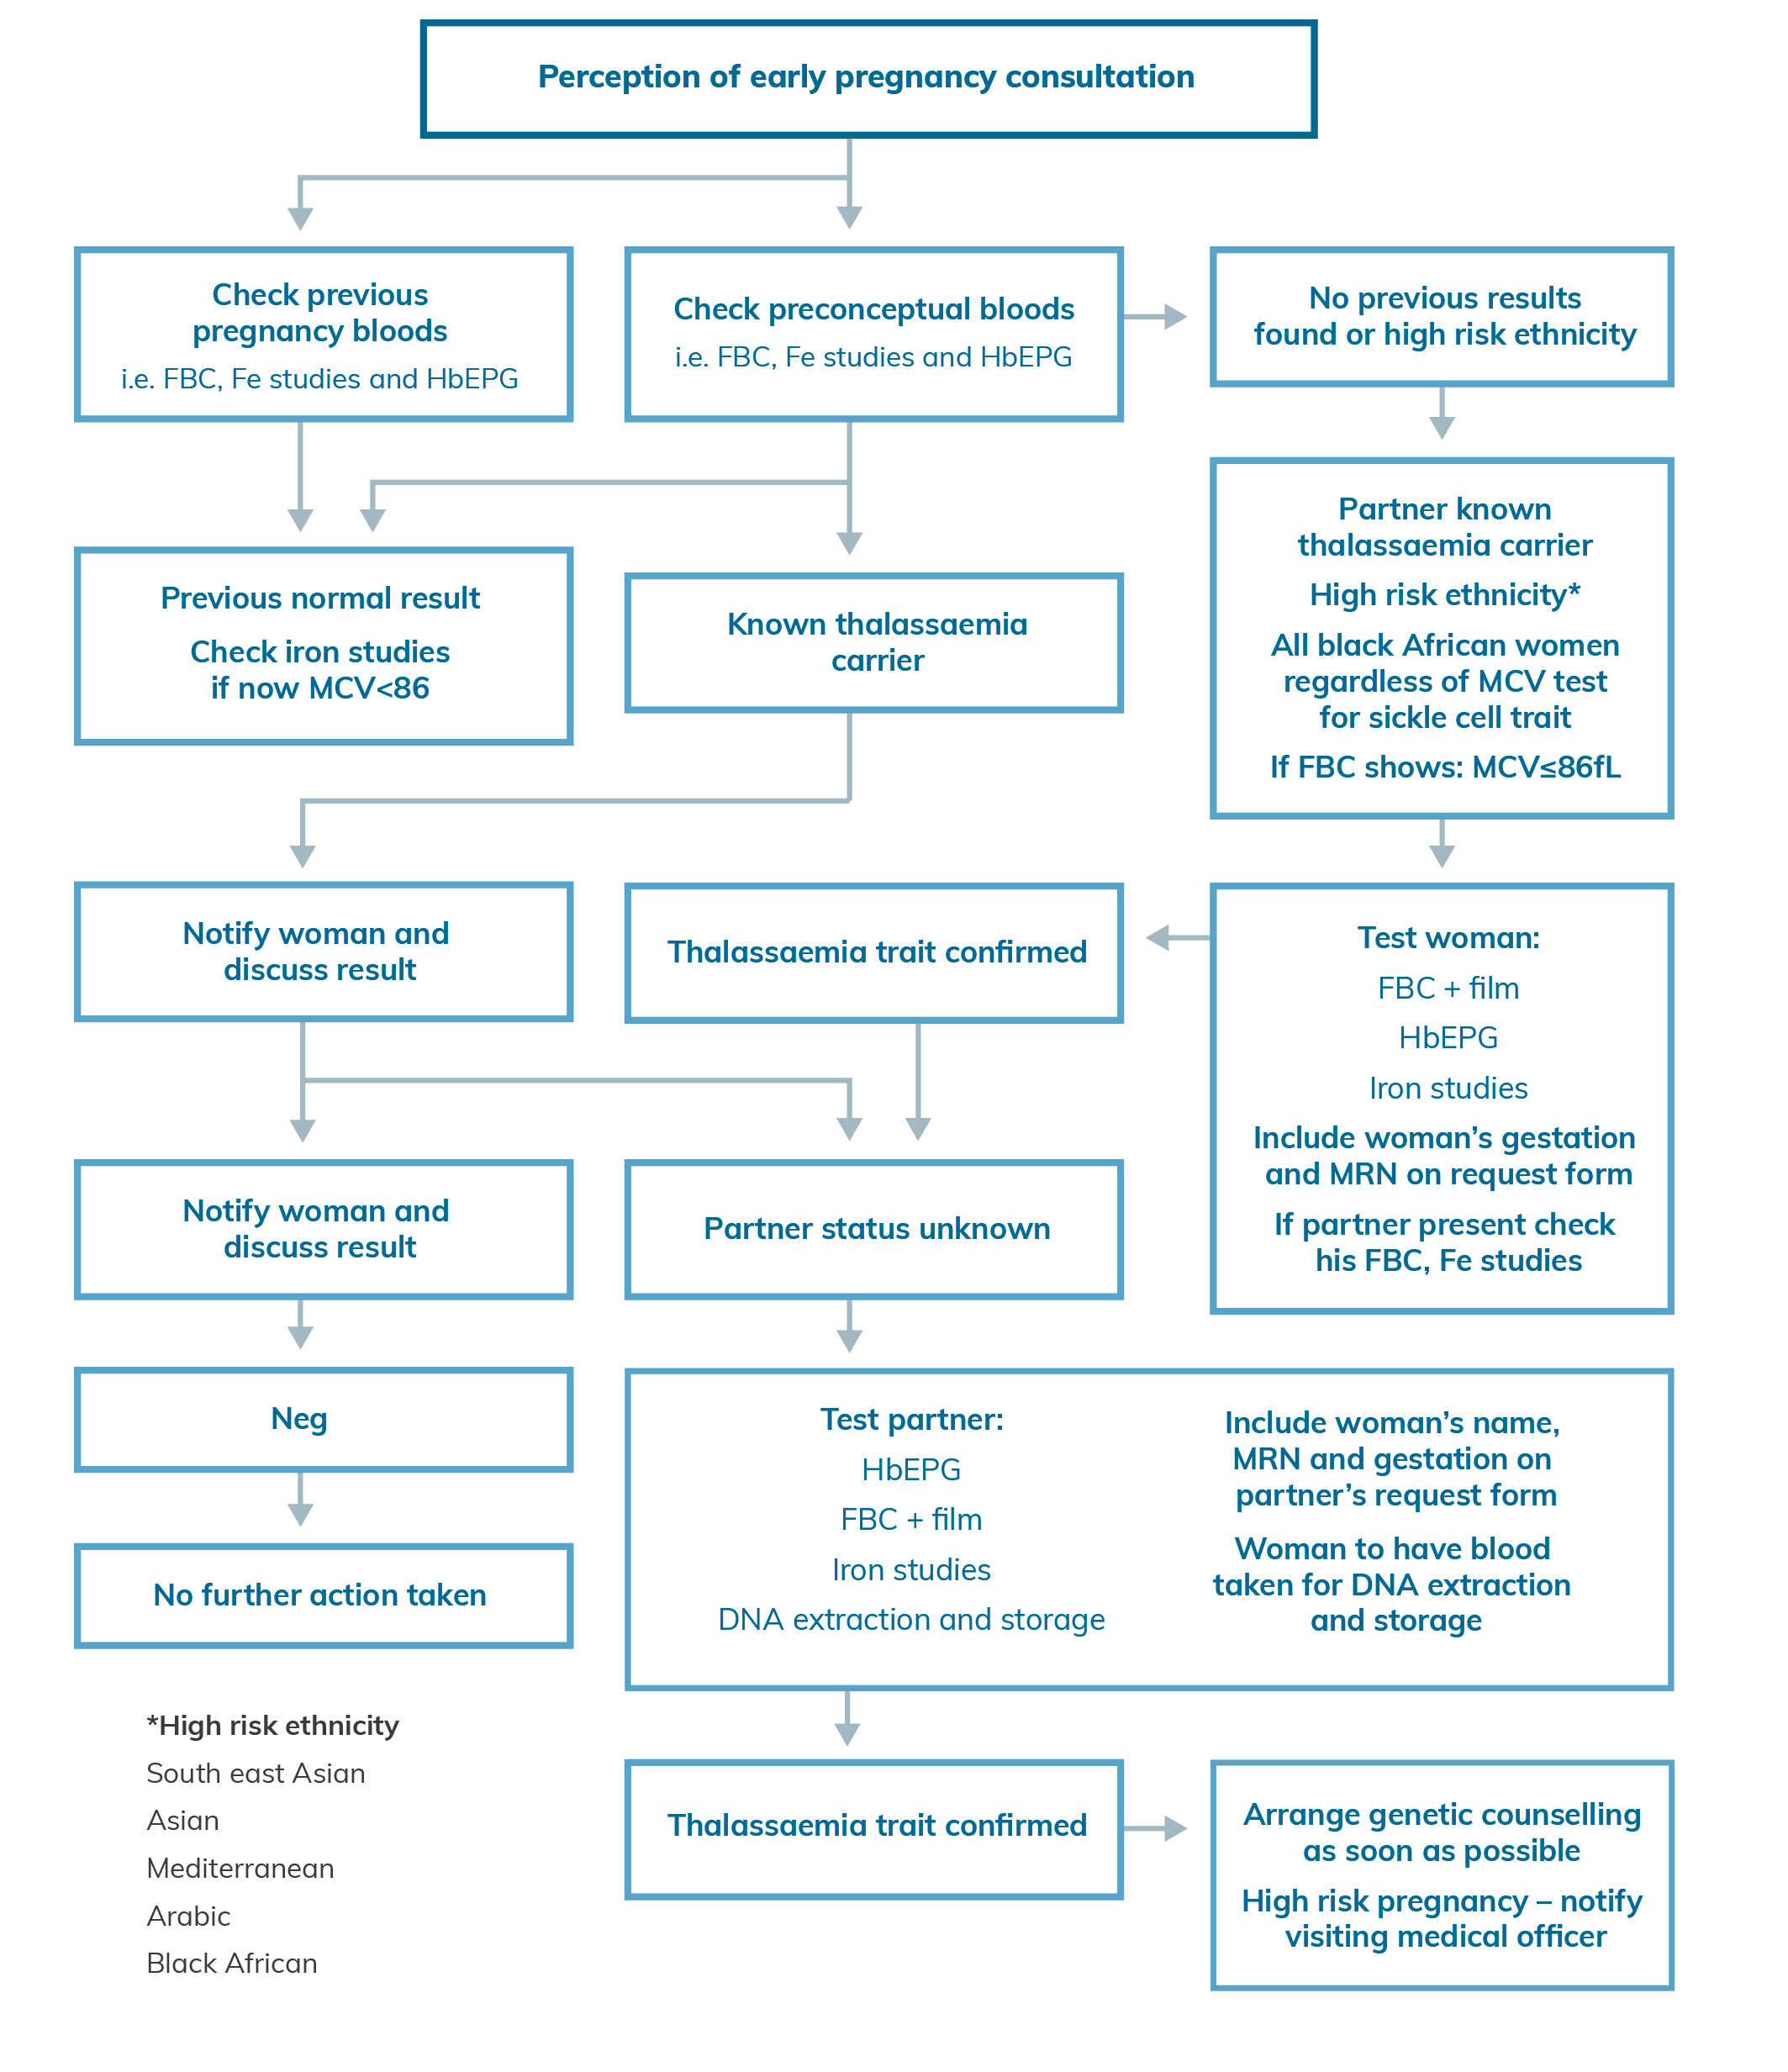
Appendix B: Hypermobility information
Joint hypermobility is common in the general population and often familial. Only a small proportion of people with joint hypermobility will require medical surveillance and genetic advice and they will usually have additional distinctive clinical features.
The relatively common hypermobility spectrum disorder (HSD); which may include individuals who meet criteria for hypermobile EDS (hEDS) can be a multisystem disorder and may have associated pain, autonomic dysfunction and psychological impact with altered quality of life. There is no known underlying genetic change for this condition and no genetic testing is available.
The clinical genetics service is not able to provide treatment or ongoing management or surveillance.
Referral is recommended to relevant medical specialists - paediatrician for children, rheumatologist, rehabilitation physician, pain physician and allied health professionals physiotherapist and occupational therapists.

Further information:
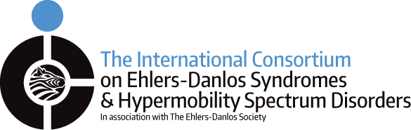
International Consortium on EDS and HSD, Diagnostic Criteria for Hypermobile Ehlers-Danlos Syndrome (hEDS)
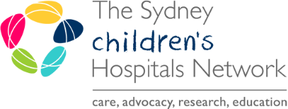
Sydney Children's Hospital Network hypermobility fact sheets
Royal College of General Practitioners UK, Ehlers-Danlos Syndromes Toolkit

Appendix C: Autism spectrum disorder information
Children and adults with autism spectrum disorder who do not have associated intellectual disability; a family history; or unusual facial features; should have baseline investigations performed by the managing doctor.
The Royal Australian College of General Practitioners (RACGP) recommends:
- referral to a paediatrician for a clinical genetics evaluation of children with autism spectrum disorder (ASD) can provide a specific diagnosis in 30-40% of cases
- general practitioners (GPs) can order a chromosome microarray (CMA) at the point of referral to a paediatrician in order to speed up this process.

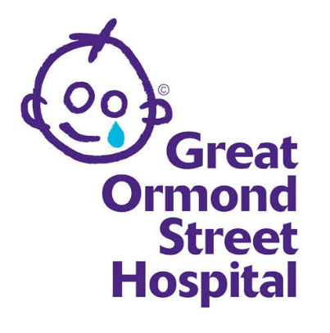
Further information:
Great Ormond Street Hospital for Children,
information on autism

Great Ormand Street Hospital for Children,
Genetics of autistic spectrum disorders,
information for families

RACGP Genomics in general practice
autism spectrum disorder

Appendix D: MTHFR Information
MTHFR is a gene that codes for an enzyme. This enzyme changes the vitamin folate in to a form that the body can use (methyl-folate). Methyl folate is important for a number of functions in the body, including regulating other genes through a process called methylation.
MTHFR stands for a gene 5,10 methylenetetrahydrofolate reductase.

Further information:

Centre for Genetics Education, Fact sheet on MTHFR.

Appendix E: Consanguinity information
When parents share a common ancestor, it is termed a ‘consanguineous’ relationship and there is an increased chance that they will both carry the same faulty gene variation. If both parents have the same gene variation, there is an increased chance of having a child with a genetic condition.

Further information:

Centre for Genetics Education, Fact sheet on Consanguinity.

Appendix F: Teratogen exposure information
Teratogens are environmental agents introduced during pregnancy that interfere with development so that they induce or increase the incidence of a congenital (structural) malformation or birth defect.
Although most recognised teratogens are drugs (prescribed or over-the-counter), they can be infections (e.g. rubella), chemicals (e.g. methyl mercury) or radiation.

Further information:

Royal Hospital for Women, MotherSafe fact sheets.

