

LUNGES



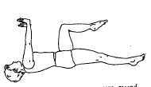

Hip Extension

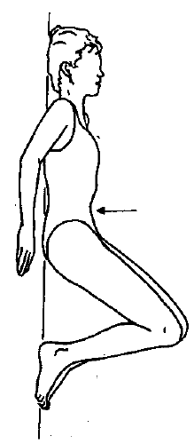

Abdominal Hollowing

****Balance/ Strength

(Step Downs)



Sit to Stand



Step Ups



Walk & Carry



Lifting

Floor to Waist

Lifting

Waist to Above Head

Balance

Standing on One Leg